Quarterly Marketing Plan For MSPs

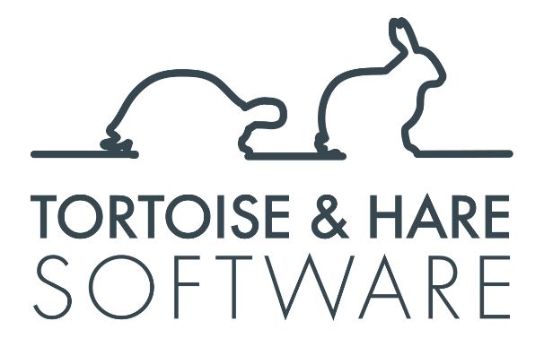

Quarterly Content Marketing Plan
This plan provides a clear roadmap for growing your MSP through consistent efforts in web content creation, YouTube video production, social media engagement, and email marketing. By building a steady cadence, you can establish a robust pipeline of high-quality marketing assets that attract new people to your brand, engage and nurture leads, and drive long-term growth.

Summary of the Plan
- Web Content Units: Create 2 high-quality pieces per month (landing pages, blog posts, case studies, or lead magnets) to enhance SEO, drive traffic, and generate brand awareness.
- YouTube Videos: Produce 2 engaging, 5–15 minute videos per month to support web content, explain services, and increase engagement.
- Social Media Posts: Post 5 days per week to promote web content, YouTube videos, testimonials, and relevant updates.
- Email Marketing: Send 1 email per month to your email list, highlighting your latest web content and YouTube videos to engage your most interested leads.
This combination of activities will build a robust set of new people coming to your brand via organic, and will help you capture both direct leads, and softer leads via email addresses. It will also help you nurture existing leads over time. This set of activities is one of the most cost-effective ways to build a flywheel that will propel an MSPs growth into the multiple millions in revenue.

Web Content Units
A web content unit is a piece of marketing content that serves as the foundation for attracting traffic, and capturing leads.
Prioritization Strategy
- If your website lacks structure or key service pages: Focus on landing pages to provide clear information about your services and improve conversions.
- If your site needs more traffic: Develop blog content to attract organic visitors and establish thought leadership.
- If your blog content is already driving traffic: Create lead magnets (checklists & other resources) to capture leads.
Activity Overview per Month
- Publish two web content units, ensuring they are optimized for SEO and linked to other relevant pages.

Creating YouTube Videos
YouTube videos enhance your web content by providing visual, engaging explanations that can be embedded on landing pages and blog posts to improve user experience and conversions.
Video Guidelines
- Length: 5–15 minutes per video.
- Purpose: Use videos as video sales letters (VSLs) or blog-enhancing content to explain services, highlight benefits, and answer common client questions.
- Content Focus:
  - VSLs for Landing Pages: Include videos on landing pages to provide clear explanations and a compelling call to action.
  - Blog-Enhancing Videos: Create visuals for blog topics, such as tutorials or industry insights.
Monthly Activities
- Produce two YouTube videos aligned with your latest web content.
- Optimize videos with SEO-friendly titles and descriptions.
- Embed videos on related web pages to help content rank and convert better

Social Media Content for MSPs
Social media allows you to amplify your marketing efforts by distributing content, engaging with prospects, and keeping your MSP top-of-mind. Platforms like LinkedIn, Facebook, and Google Business Profile are especially effective for MSPs.
Monthly Activities
- Post five days per week consistently, focusing on:
  - Promoting Website Content: Share blog posts, landing pages, or lead magnets with engaging captions.
  - Promoting YouTube Videos: Share links to your videos, driving views and traffic to related web content. Upload video natively to the social media platform where possible.
  - Showcasing Social Proof: Highlight client reviews to build trust and credibility. Share case studies.
  - Filling Content Gaps: Share trending industry topics, employee milestones, or cultural moments like community involvement or networking events when you don’t have existing web content to promote.
Building a Sustainable Content Pipeline
- Use Publer to automate posting and schedule evergreen content for quarterly re-promotion.
- Over time, shift focus to maintaining a pipeline of high-performing content rather than creating a new 5-day-per-week schedule each month.
- Replace underperforming posts with fresh content to keep your pipeline dynamic and effective.

Email Marketing
Email marketing is a crucial channel for engaging your most interested leads, as not everyone uses social media. Monthly emails allow you to highlight your latest content directly to your audience, fostering trust, nurturing leads, and keeping your brand top-of-mind.
Monthly Email Activities
- Frequency: Send one email per month to your email list.
- Content Focus:
  - Highlight your latest web content, such as blog posts or landing pages, with a brief summary and a link to the full content.
  - Promote your latest YouTube videos, explaining their relevance and encouraging recipients to watch.
- Tone: Keep the email concise, professional, and value-driven. Make it clear how the content helps your audience solve their problems.
- Automation: Use email marketing tools like Mailchimp or ActiveCampaign to design, schedule, and analyze the performance of your email campaigns.

What to Do After 90 Days
At the end of the first quarter, focus on improving efficiency and content quality as you re-execute the plan for the next quarter. Content in the MSP space takes time to deliver results due to long sales cycles, so consistency and re-promotion are critical.
Focus Areas for the Next Quarter
- Streamline Processes:
  - Refine workflows for content creation, video production, and email marketing to reduce time while maintaining quality.
  - Automate repetitive tasks using tools like Publer for social media and email marketing software.
- Enhance Content Quality:
  - Deepen the expertise and relevance of your content to address your audience’s pain points more effectively.
  - For YouTube, focus on improving scripting, editing, and visuals to better engage viewers.
- Refine the Content Pipeline:
  - Focus on re-promoting your best-performing blog posts, videos, and social media posts.
  - Replace underperforming content with fresh ideas to maintain a dynamic and effective marketing strategy.
- Think Long-Term:
  - Evaluate performance more closely after a full year of consistent execution, as content takes time to generate measurable ROI in the MSP space.

What’s Next?
Executing this quarterly marketing plan will build a flywheel for your MSP that will generate consistent lead volume over time. At a certain point you will need to do more though, and it doesn’t always make sense to just increase content volume. Too much content can lead to SEO problems, and a decline in content quality. Often it makes more sense to start advertising and start being more purposeful with your strategy. Engaging a marketing agency can make a lot of sense here. Reach out to Tortoise and Hare for help scaling up your marketing efforts:
https://tortoiseandharesoftware.com/

Web Content Units
- Landing page, blog post, or lead magnet
- Landing page, blog post, or lead magnet
- Landing page, blog post, or lead magnet
- Landing page, blog post, or lead magnet
- Landing page, blog post, or lead magnet
YouTube Videos
- Video Topic
- Video Topic
- Video Topic
- Video Topic
- Video Topic
Social Media Posts
Use this excel spreadsheet to plan out your social media content

